Notes: Create a Jira ticket for this assignment, Provide detailed step-by-step instructions for the installation process along with proper evidence (Outputs, and screenshots). You may refer to YouTube tutorials or Google resources for guidance, and submit the challenge completion document by EOD.
- Launch one aws ec2 and install jenkins.
- Setup Apache Tomcat on Ubuntu Virtual Machine
- Setup Docker Desktop on your local windows.

- Launched a EC2 instance with name Jenkins server with ubuntu image.

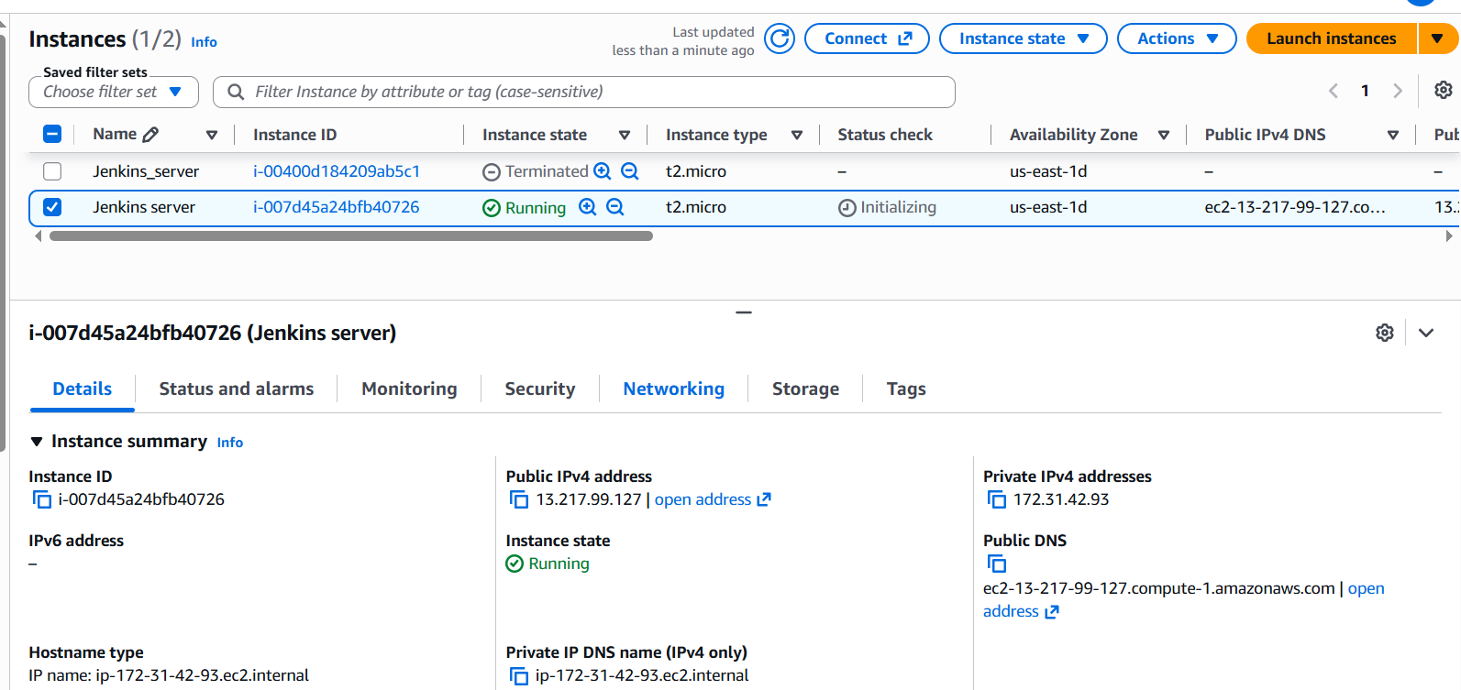

- Successfully connected via Mobaxterm using

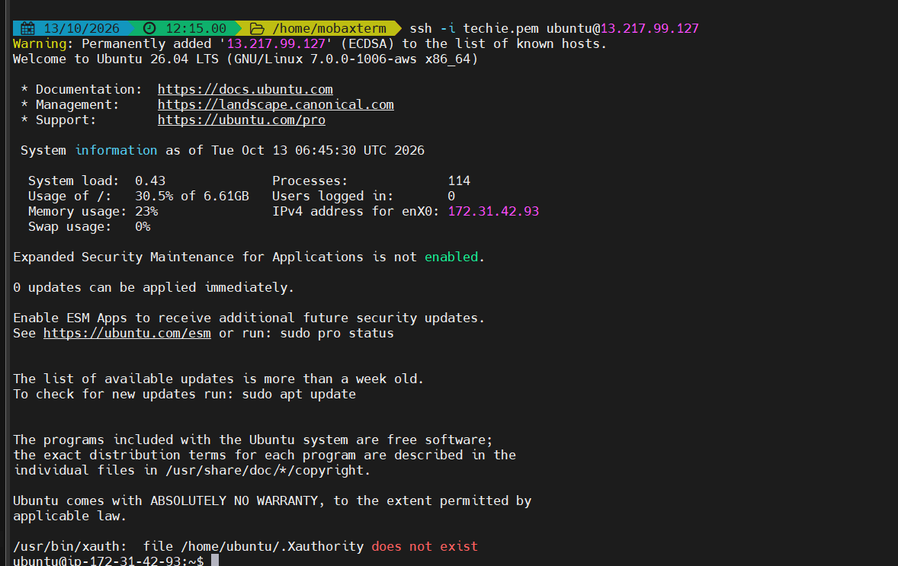
JEKINS INSTALLATION SCRIPT.
• sudo apt update
• sudo apt install fontconfig openjdk-21-jre
• java -version

sudo wget -O /etc/apt/keyrings/jenkins-keyring.asc \
https://pkg.jenkins.io/debian-stable/jenkins.io-2026.key
echo "deb [signed-by=/etc/apt/keyrings/jenkins-keyring.asc]" \
https://pkg.jenkins.io/debian-stable binary/ | sudo tee \
/etc/apt/sources.list.d/jenkins.list > /dev/null

• sudo apt update
• sudo apt install Jenkins
• sudo systemctl enable --now jenkins
• sudo systemctl start Jenkins
• sudo systemctl status jenkins

for admin password first time use
$ cat /var/lib/jenkins/secrets/initialAdminPassword

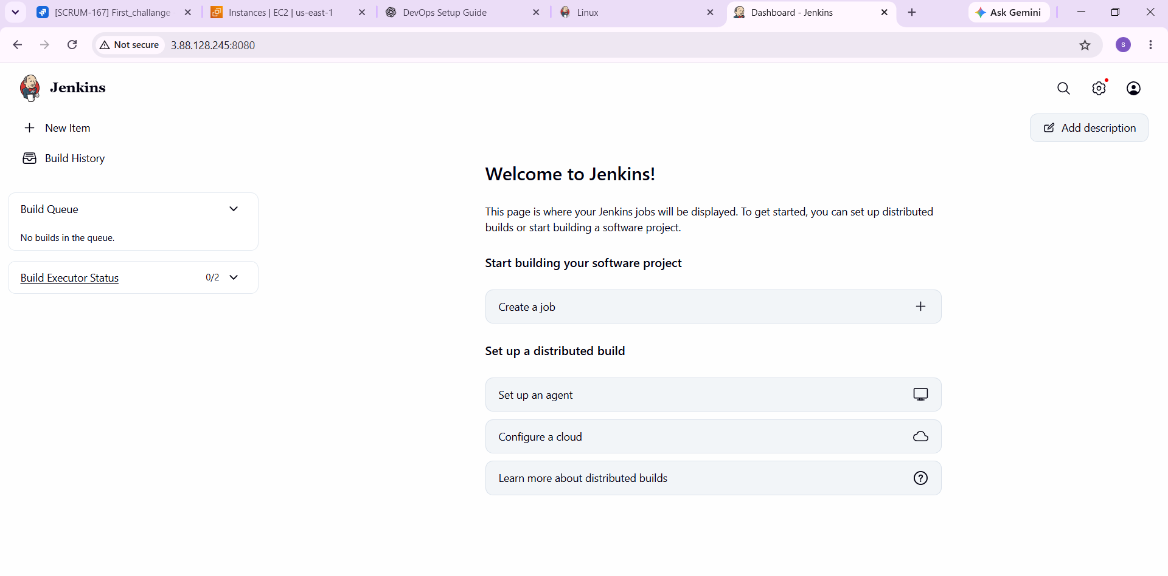

TOMCAT INSTALLATION SCRIPT
- sudo apt update
- sudo apt install -y openjdk-21-jdk
- java -version

- sudo apt install -y tomcat10

- sudo systemctl enable --now tomcat10
- sudo systemctl status tomcat10

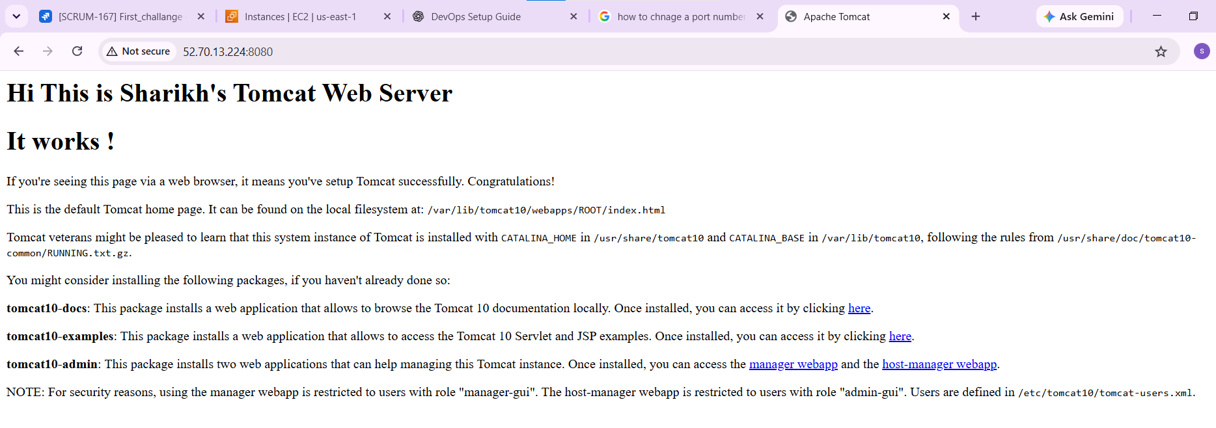

Setup Docker Desktop on your local windows

